SOFT COMPUTING

FUZZY GAME

WEA150022 ONG JIA AUN

1. Neslo is a Malaysian drink which contains a mixture of Nescafe coffee and Milo malt drinks. Develop a membership function of Neslo. Draw a diagram for the membership function of Neslo. Justify the shape of the membership function you developed.

(4 *marks*)

1. Membership function:

x = ratio of amount of Milo to amount of Nescafe

f(x) = degree of membership of Neslo

In a triangle shape function:

range of x from 0 to 2

when x = 1, f(x) = 1

when x <= 0.5, f(x) = 0

when x >= 1.5, f(x) = 0

1. 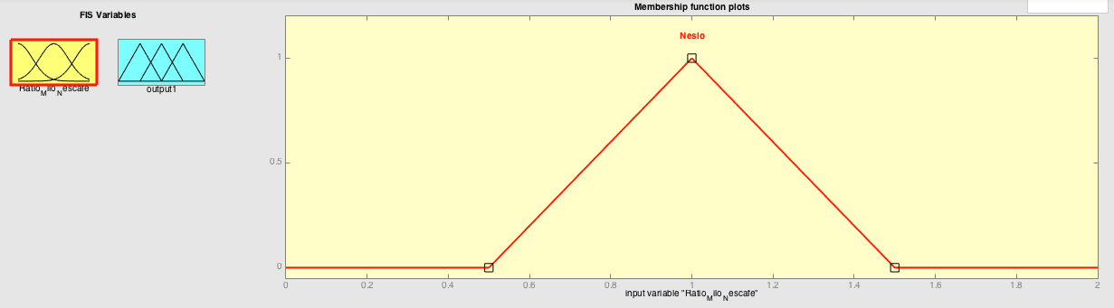
2. With max degree of membership 1 when x = 1, this translates to 1 spoonful of Milo to 1 spoonful of Nescafe. This is because most Malaysian enjoys a balanced taste of blended Milo and Nescafe, especially me.
3. The degree of membership drops to 0 when x <= 0.5 or x >= 1.5 because then there will be too much Milo over Nescafe or too much Nescafe over Milo. The taste will be off.

2. Cham is another Malaysian drink consists of mixture of coffee and tea. Develop a membership function of Cham. Draw a diagram for the membership function of Cham. Insert into the diagram membership function of coffee and membership function of tea.

(4 *marks*)

1. Membership function:

x = ratio of amount of Coffee to amount of Tea

f(x) = degree of membership of Cham

In a triangle shape function:

range of x from 0 to 2

when x = 1, f(x) = 1

when x <= 0.5, f(x) = 0

when x >= 1.5, f(x) = 0

1. 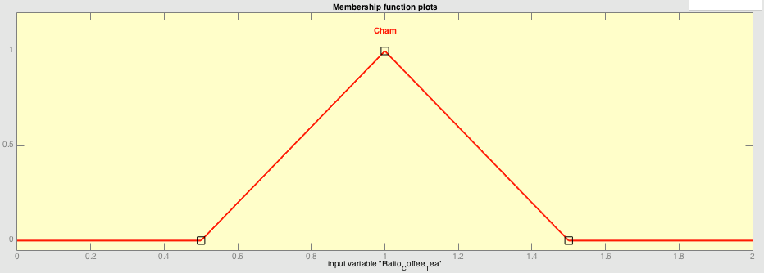
2. 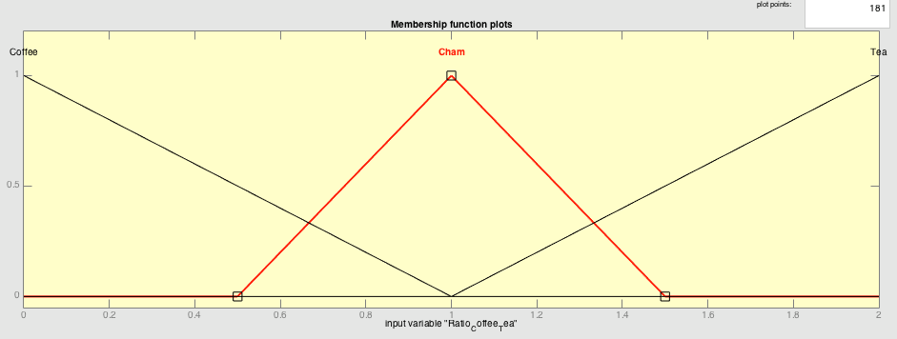

3. The Apple iPhone X has Face ID for facial recognition as a secure login mechanism. Is fuzzy logic suitable for Face ID implementation? Provide justifications for your answer.

(2 *marks*)

1. Fuzzy logic is not very suitable for Face ID to an extent.
2. The system should rely on not just fuzzy logic for the facial recognition.
3. This is because fuzzy logic might allow a close enough facial features to pass, but a neural network will not allow
4. This being said, having a fuzzy logic for the system will aid in recognizing face where neural network might fail by having a leeway for recognition